DIS-PAC-POLY-Hula-1822

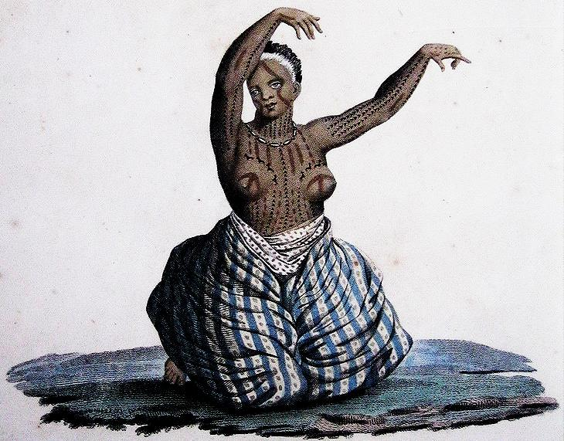 Antique Hawaiian Print: "**ILES SANDWICH, FEMME DE L'ILE MOWI DANSANT**",   
 circa: 1822, antique color print from a copper-plate engraving from Jacques Arago's original,  
 published in Voyage Around the World, Paris,  no printing on reverse, condition: VG foxing   
 stains, minor edge wear. Jacques Arago was the artist who accompanied Captain Louis De  
 Freycinet on the corvette ship "Uranie", commissioned by the French government for a  
 scientific voyage in 1817. "Iles Sandwich, Femme De L'ile Mowi Dansant", shows a Native  
 Hawaiian woman with tattoos her hair bleached a white strip, wearing a shell necklace and   
 trade-cloth dress while seated in a traditional Hula pose.   
                                               size: 13" inch x 19 1/2" inch